**Lecture Note**

**On**

**Basic Civil Engineering**

**Course Code (RBC2B002)**

**SYLLABUS**

MODULE-I (6 classes)

Introduction and Scope of Civil Engineering. Broad disciplines of Civil Engineering; Importance of Civil Engineering, Early constructions and developments over time, Development of various materials of construction and methods of construction. Building Material and Building Construction: Bricks: Brick as a construction material and its importance, qualities of a good brick, Stone: classification, composition and characteristics, Cement: Classification, tests for cement, uses of cement, types of cement, Concrete: Quality of mixing water, Workability, Compaction of concrete, concrete mix design, Grade and strength of Concrete. Fundamentals of R.C.C. and Prestressed concrete. Types of steels used in civil engineering works. Building Components and their basic requirements, Mortar, Stone masonry, brick masonry, roof, floors.

MODULE-II (6 classes)

Surveying: Linear measurement and chain survey: Use of chains and tapes for measurement of correct length of lines, direct and indirect ranging,Compass surveying: Use of prismatic compass, bearing of a line. Local attraction, Introduction to modern surveying instruments EDM and Total Station.

MODULE-III (6 classes)

Fundamental of soil and its classification, Foundations: Types of shallow and deep foundations with neat sketches. Fundamentals of Irrigation Engineering. Introduction of Hydraulics structure like canals, siphons, weirs, dams etc.

MODULE-IV (6 classes)

Transport, Traffic and Urban Engineering: Introduction to planning and design aspects of transportation engineering, different modes of transport, highway engineering, rail engineering, airport engineering, traffic engineering, urban engineering

TEXT BOOKS

1. Basic Civil Engineering, S. Gopi, Pearson
2. Building Construction, Sushil Kumar, Standard Publishers Distributors
3. Surveying and Levelling by R. Subramanian, Oxford UniversityPress

REFERENCE BOOKS

1. Engineering Materials, S.C. Rangwala, Charotar Publishing House
2. Building Material and Construction, G C Sahu, Joygopal Jena, McGrow Hill
3. Surveying Vol-1 by R Agor, Khanna Publishers
4. Basic Civil Engineering, M.S. Palanichamy, McGraw Hill

**MODULE – I**

Introduction and Scope of Civil Engineering:

Civil engineering is the art of directing the great sources of power in nature for the use and convenience of man. Basically it is concerned with planning, design and construction for environmental control, development of natural resource, buildings, transportation facilities and other structures required for health, welfare, safety, employment and pleasure of mankind.

The main scope of civil engineering is planning, designing, estimating, supervising, managing and maintenance of structures like building, roads, bridges, dams etc.

Broad disciplines of Civil Engineering:

Civil engineering is a wide field and includes many types of structures such as residential buildings, public buildings, industrial buildings, roads, bridges, tunnels,railways, dams, canals, airports, harbours, waste water treatment plants, water supply networks and drainage networks, drainage networks etc.

According to the type of structures and activities carried out, main branches of civil engineering are classified as follows:

* Structural Engineering
* Geotechnical Engineering
* Transportation Engineering
* Environmental Engineering
* Water resources Engineering
* Surveying and levelling

Building Material and Building Construction:

**Brick**

* Brick is a small rectangular block obtained by moulding good clay into a block, which is dried and then burnt.
* A brick is one of the oldest building material used to make walls, pavements and other elements in masonry construction.
* The standard size of brick is 190 mm X 90 mm X 90 mm and the nominal size (including mortar thickness) of brick is 200 mm X 100 mm X 100 mm.

Qualities of a good brick

The following are the required properties of good bricks:

(*i*) Colour: Colour should be uniform and bright.

(*ii*) Shape: Bricks should have plane faces. They should have sharp and true right angled corners.

(*iii*) Size: Bricks should be of standard sizes as prescribed by codes.

(*iv*) Texture: They should possess fine, dense and uniform texture. They should not possess fissures, cavities, loose grit and unburnt lime.

(*v*) Soundness: When struck with hammer or with another brick, it should produce metallic sound.

(*vi*) Hardness: Finger scratching should not produce any impression on the brick.

(*vii*) Strength: Crushing strength of brick should not be less than 3.5 N/mm2. A field test for strength is that when dropped from a height of 0.9 m to 1.0 mm on a hard ground, the brick should not break into pieces.

(*viii*) Water Absorption: After immersing the brick in water for 24 hours, water absorption should

not be more than 20 per cent by weight.

(*ix*) Efflorescence: Bricks should not show white patches when soaked in water for 24 hours and then allowed to dry in shade. White patches are due to the presence of sulphate of calcium, magnesium and potassium. They keep the masonry permanently in damp and wet conditions.

(*x*) Thermal Conductivity: Bricks should have low thermal conductivity, so that buildings built with them are cool in summer and warm in winter.

(*xi*) Sound Insulation: Heavier bricks are poor insulators of sound while light weight and hollow provide good sound insulation.

(*xii*) Fire Resistance: Fire resistance of bricks is usually good. In fact bricks are used to encase steel columns to protect them from fire.

Importance of Bricks

Bricks are used in the following civil works:

(*i*) As building blocks.

(*ii*) For lining of ovens, furnaces and chimneys.

(*iii*) For protecting steel columns from fire.

(*iv*) As aggregates in providing water proofing to R.C.C. roofs.

(*v*) For pavers for footpaths and cycle tracks.

(*vi*) For lining sewer lines.

Constituents of good brick earth:

Bricks are the most commonly used construction material. Bricks are prepared by moulding clay in rectangular blocks of uniform size and then drying and burning these blocks. In order to get a good quality brick, the brick earth should contain the following constituents.

* Silica
* Alumina
* Lime
* Iron oxide
* Magnesia

Silica

* Brick earth should contain about 50 to % of silica.
* It is responsible for preventing cracking, shrinking and warping of raw bricks.
* It also affects the durability of bricks.
* If present in excess, then it destroys the cohesion between particles and the brick becomes brittle.

Alumina

* Good brick earth should contain about 20% to 30% of alumina.
* It is responsible for plasticity characteristic of earth, which is important in moulding operation.
* If present in excess, then the raw brick shrink and warp during drying.

Lime

* The percentage of lime should be in the range of 5% to 10% in a good brick earth.
* It prevents shrinkage of bricks on drying.
* It causes silica in clay to melt on burning and thus helps to bind it.
* Excess of lime causes the brick to melt and brick looses its shape.

Iron oxide

* A good brick earth should contain about 5% to 7% of iron oxide.
* It gives red colour to the bricks.
* It improves impermeability and durability.
* It gives strength and hardness.
* If present in excess, then the colour of brick becomes dark blue or blakish.
* If the quantity of iron oxide is comparatively less, the brick becomes yellowish in colour.

Magnesia

* Good brick earth should contain less a small quantity of magnesia about1%)
* Magnesium in brick earth imparts yellow tint to the brick.
* It is responsible for reducing shrinkage
* Excess of magnesia leads to the decay of bricks.

Classification of Bricks as per common practice:

Bricks, which are used in construction works, are burnt bricks. They are classified into four

categories on the basis of its manufacturing and preparation, as given below.

1. First class bricks

2. Second class bricks

3. Third class bricks

4. Fourth class bricks

**Stones**

Stone is a ‘naturally available building material’ which has been used from the early age of civilization. It is available in the form of rocks, which is cut to required size and shape and used as building block.It has been used to construct small residential buildings to large palaces and temples all over the world.

Type of Stones

Stones used for civil engineering works may be classified in the following four ways:

* Geological
* Physical
* Chemical
* Practical

*Geological Classification*

Based on their origin of formation stones are classified into three main groups—Igneous, sedimentary and metamorphic rocks.

(i)Igneous Rocks: These rocks are formed by cooling and solidifying of the rock masses from their molten magmatic condition of the material of the earth. Generally igneous rocks are strong and durable. Granite, trap and basalt are the rocks belonging to this category, Granites are formed by slow cooling of the lava under thick cover on the top. Hence they have crystalline surface. The cooling of lava at the top surface of earth results into non-crystalline and glassy texture. Trap and basalt belong to this category.

(*ii*) Sedimentary Rocks: Due to weathering action of water, wind and frost existing rocks disintegrates. The disintegrated material is carried by wind and water; the water being most powerful medium. Flowing water deposits its suspended materials at some points of obstacles to its flow. These deposited layers of materials get consolidated under pressure and by heat. Chemical agents also contributeto the cementing of the deposits. The rocks thus formed are more uniform, fine grained and compact intheir nature. They represent a bedded or stratified structure in general. Sand stones, lime stones, mudstones etc. belong to this class of rock.

(*iii*) Metamorphic Rocks: Previously formed igneous and sedimentary rocks undergo changesdue to metamorphic action of pressure and internal heat. For example due to metamorphic action granitebecomes greisses, trap and basalt change to schist and laterite, lime stone changes to marble, sand stonebecomes quartzite and mud stone becomes slate.

*Physical Classification*

Based on the structure, the rocks may be classified as:

* Stratified rocks
* Unstratified rocks

(*i*) Stratified Rocks: These rocks are having layered structure. They possess planes ofstratification or cleavage. They can be easily split along these planes. Sand stones, lime stones, slate etc.are the examples of this class of stones.

(*ii*) Unstratified Rocks: These rocks are not stratified. They possess crystalline and compactgrains. They cannot be split in to thin slab. Granite, trap, marble etc. are the examples of this type ofrocks.

(*iii*) Foliated Rocks: These rocks have a tendency to split along a definite direction only. Thedirection need not be parallel to each other as in case of stratified rocks. This type of structure is verycommon in case of metamorphic rocks.

*Chemical Classification*

On the basis of their chemical composition engineers prefer to classify rocks as:

* Silicious rocks
* Argillaceous rocks and
* Calcareous rocks

(*i*) Silicious rocks:The main content of these rocks is silica. They are hard and durable. Examples of such rocks are granite, trap, sand stones etc.

(*ii*) Argillaceous rocks:The main constituent of these rocks is argil *i.e.*, clay. These stones are hard and durable but they are brittle. They cannot withstand shock. Slates and laterites are examples of this type of rocks.

(*iii*) Calcareous rocks:The main constituent of these rocks is calcium carbonate.

*Practical Classification*

The example of such stones are granite, basalt, laterite, marble, limestone, sandstone and slate.

Requirements of Good Building Stones

The following are the requirements of good building stones:

(*i*) Strength: The stone should be able to resist the load coming on it. Ordinarily this is not of primary concern since all stones are having good strength. However in case of large structure, it may be necessary to check the strength.

(*ii*) Durability: Stones selected should be capable of resisting adverse effects of natural forces like wind, rain and heat.

(*iii*) Hardness: The stone used in floors and pavements should be able to resist abrasive forces caused by movement of men and materials over them.

(*iv*) Toughness: Building stones should be tough enough to sustain stresses developed due to vibrations. The vibrations may be due to the machinery mounted over them or due to the loads moving over them. The stone aggregates used in the road constructions should be tough.

(*v*) Specific Gravity: Heavier variety of stones should be used for the construction of dams, retaining walls, docks and harbours. The specific gravity of good building stone is between 2.4 and 2.8.

(*vi*) Porosity and Absorption: Building stone should not be porous. If it is porous rain water enters into the pour and reacts with stone and crumbles it. In higher altitudes, the freezing of water in pores takes place and it results into the disintegration of the stone.

(*vii*) Dressing: Giving required shape to the stone is called dressing. It should be easy to dress so that the cost of dressing is reduced. However the care should be taken so that, this is not be at the cost of the required strength and the durability.

(*viii*) Appearance: In case of the stones to be used for face works, where appearance is a primary requirement, its colour and ability to receive polish is an important factor.

(*ix*) Seasoning: Good stones should be free from the quarry sap. Laterite stones should not be used for 6 to 12 months after quarrying. They are allowed to get rid of quarry sap by the action of nature. This process of removing quarry sap is called seasoning.

(*x*) Cost: Cost is an important consideration in selecting a building material. Proximity of the quarry to building site brings down the cost of transportation and hence the cost of stones comes down.

**Cement**

Cement is a material with adhesive and cohesive properties which make it capable of bonding minerals fragments into a compact whole.For constructional purposes, the meaning of the term "cement" is restricted to the bonding materials used with stones, sand, bricks, building stones, etc.

The name "Portland cement" given originally due to the resemblance of the color and quality of the hardened cement to Portland stone – Portland Island in England.

Manufacturing Process of Portland cement

Raw materials

• Calcareous material – such as limestone or chalk, as a source of lime (CaO).

• Clayey material – such as clay or shale (soft clayey stones), as a source of silica and alumina.

Methods of cement manufacturing

1- Wet process - grinding and mixing of the raw materials in the existence of water.

2- Dry process - grinding and mixing of the raw materials in their dry state.

The process to be chosen, depend on the nature of the used raw materials.

Wet process – the percentage of the moisture in the raw materials is high.

Dry process –

• The raw materials is so hard (solid) that they do not disintegrate by water

• Cold countries, because the water might freeze in the mixture

• Shortage of the water needed for mixing process.

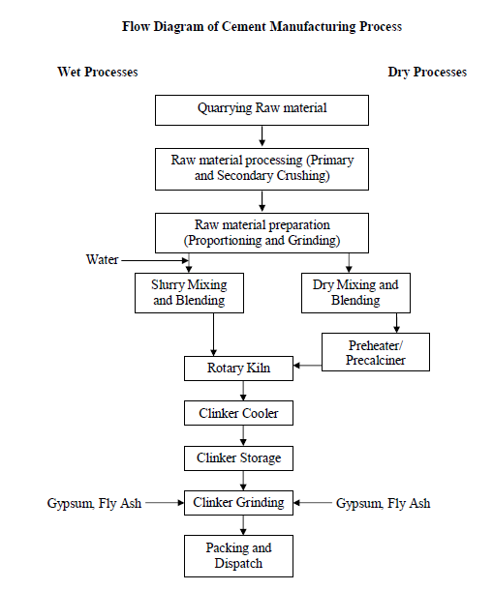

*Wet process*

When chalk is used, it is finely broken up and dispersed in water in a washmill. The clay is also broken up and mixed with water, usually in a similar washmill. The two mixtures are now pumped so as to mix in predetermined proportions and pass through a series of screens. The resulting – cement slurry – flows into storage tanks.

When limestone is used, it has to be blasted, then crushed, usually in two progressively smaller crushers (initial and secondary crushers), and then fed into a ball mill with the clay dispersed in water. The resultant slurry is pumped into storage tanks. From here onwards, the process is the same regardless of the original nature of the raw materials.

The slurry is a liquid of creamy consistency, with water content of between 35 and 50%. The slurry mix mechanically in the storage tanks, and the sedimentation of the suspended solids being prevented by bubbling by compressed air pumped from bottom of the tanks. The slurry with the desired lime content passes into the rotary kiln. Its movement down the kiln, encounters a progressively higher temperature. The mass then fuses into balls, 3 to 25 mm in diameter, known as clinker. The clinker drops into coolers.

*Dry process*

The raw materials are crushed and fed in the correct proportions into a grinding mill, where they are dried and reduced in size to a fine powder. The dry powder, called raw meal, is then pumped to a blending silo, and final adjustment is now made in the proportions of the materials required for the manufacture of cement. To obtain a uniform mixture, the raw meal is blended in the silo, usually by means of compressed air.

The blended meal is sieved and fed into a rotating dish called a granulator, water weighing about 12% of the meal being added at the same time. In this manner, hard pellets about 15 mm in diameter are formed.

The pellets are baked hard in a pre-heating grate by means of hot gases from the kiln. The pellets then enter the kiln, and subsequence operations are the same as in the wet process of manufacture.

Grinding of the clinker

The cool clinker (produced by wet or dry process), which ischaracteristically black and hard, is interground with gypsum in order to prevent flash setting of the cement, and to facilitate the grinding process. The grinding is done in a ball mill. The cement discharged by the mill is passed through a separator, fine particles being removed to the storage silo by an air current, while the coarser particles are passed through the mill once again.

Use

• Cement mortar for Masonry work, plaster and pointing etc.

• Concrete for laying floors, roofs and constructing lintels,beams,weathershed,stairs,pillars etc.

• Construction for important engineering structures such,culverts,dams,tunnels,light house, blocks,etc.

• Construction of water wells, tennis courts,septic tanks, lamp posts, telephone cabins etc.

• Making joint for joints,pipes,etc.

• Manufacturing of precast pipes,garden seats, artistically designed wens, flower posts, etc.

• Preparation of foundation, water tight floors, footpaths, etc.

Types of Cements

Many types of cements are available in markets with different compositions and for use in different environmental conditions and specialized applications. A list of some commonly used cement is described in this section:

Ordinary Portland Cement

Ordinary Portland cement is the most common type of cement in general use around the world. This cement is made by heating limestone (calcium carbonate) with small quantities of other materials (such as clay) to 1450°C in a kiln, in a process known as calcination, whereby a molecule of carbon dioxide is liberated from the calcium carbonate to form calcium oxide, or quicklime, which is then blended with the other materials that have been included in the mix. The resulting hard substance, called 'clinker', is then ground with a small amount of gypsum into a powder to make 'Ordinary Portland Cement'(often referred to as OPC).

This type of cement use in construction when there is no exposure to sulphates in the soil or ground water.

Rapid hardening Portland cement

* It is firmer than Ordinary Portland Cement
* It contains more C3S are less C2S than the ordinary Portland cement.
* Its 3 days strength is same as 7 days strength of ordinary Portland cement.

Low Heat Portland cement

* Heat generated in ordinary Portland cement at the end of 3days 80 cal/gm. While in low heat cement it is about 50cal/gm of cement.
* It has low percentage of C3A and relatively more C2S and less C3A than O.P. Cement.
* Reduce and delay the heat of hydration.

Sulphate resisting Portland cement

* Maximum C3A content by 3.5% and minimum fineness by 2500 cm2/g.
* Firmer than ordinary pot land cement.
* Sulphate forms the sulpha-aluminates which have expensive properties and so causes disintegration of concrete.

Blast Furnace Slag Cement

* For this cement, the slag as obtained from blast furnace is used
* The clinkers of cement are ground with about 60 to 65 percent of slag.
* Its strength in early days is less and hence it required longer curing period.
* It proves to be economical as slag, which is a Waste product, is used in its manufactures.

Portland Pozzolana cement

* As per Indian standard, the proportions of Pozzolana may be 10 to 25 % by weight. e.2. Burnt clay, shale, Fly ash.
* This Cement has higher resistance to chemical agencies and to sea water because of absence of lime.
* It evolves less heat and initial strength is less but final strength is 28 days onward equal to ordinary Portland cement.
* It possesses less resistance to the erosion and weathering action.
* It imparts higher degree of water tightness and it is cheap.

White cement

* Grey colour of O.P. cement is due to presence of Iron Oxide. Hence in White Cement FeO, is limited to 1 %. Sodium Alumina Ferrite (Crinoline) NavAlF6 is added to act as flux in the absence of Iron-Oxide.
* It is quick drying, possesses high strength and has superior aesthetic values and it also cost less than ordinary Cement because of specific requirements imposed upon the raw materials and the manufacturing process.
* White Cement are used in Swimming pools, for painting garden furniture, moulding sculptures and statues etc.

Coloured cement

* The Cement of desired colour may be obtained by mixing mineral pigments with ordinary Cement.
* The amount of colouring material may vary from 5 to 10 percent. If this percentage exceeds 10percent, the strength of cements is affected.
* The iron Oxide in different proportions gives brown, red or yellow colour. The coloured Cement are widely used for finishing of floors, window sill slabs, stair treads etc.

Expansive cement

* This type of cement is produced by adding an expanding medium like sulphoaluminate and a stabilising agent to the ordinary cement.
* The expanding cement is used for the construction of water retaining structures and for repairing the damaged concrete surfaces.

High alumina cement

* This cement is produced by grilling clinkers formed by calcining bauxite and lime. It can stand high tempertures.
* If evolves great heat during setting. It is therefore not affected by frost.

Various tests on Cement:

Basically two types of tests are under taken for assessing the quality of cement.

Field test:

There are four types of field tests to access the colour, physical property, and strength of the cement as described below.

*Colour*

* The colour of cement should be uniform.
* It should be typical cement colour i.e. grey colour with a light greenish shade.

*Physical properties*

* Cement should feel smooth when touched between fingers.
* If hand is inserted in a bag or heap of cement,it should feel cool.

*Presence of lumps*

* Cement should be free from lumps.
* For a moisture content of about 5 to 8%,this increase of volume may be much as 20 to 40 %,depending upon the grading of sand.

*Strength*

* A thick paste of cement with water is made on a piece of thick glass and it is kept under water for 24 hours.It should set and not crack.

Laboratory tests:

Six laboratory tests are conducted mainly for assessing the quality of cement. These are: fineness, compressive strength, consistency, setting time, soundness and tensile strength.

*Fineness*

* This test is carried out to check proper grinding of cement.
* The fineness of cement particles may be determined either by sieve test or permeability apparatus test.
* In sieve test,the cement weighing 100 gram is taken and it is continuously passed for 15 minutes through standard BIS sieve no. 9.The residue is then weighed and this weight should not be more than 10% of original weight.
* In permeability apparatus test,specific area of cement particles is calculated. This test is better than sieve test. The specific surface acts as a measure of the frequency of particles of average size.

*Compressive strength*

* This test is carried out to determine the compressive strength of cement.
* The mortar of cement and sand is prepared in ratio 1:3.
* Water is added to mortar in water cement ratio 0.4.
* The mortar is placed in moulds.The test specimens are in the form of cubes and the moulds are of metals.For 70.6 mm and 76 mm cubes ,the cement required is 185gm and 235 gm respectively.
* Then the mortar is compacted in vibrating machine for 2 minutes and the moulds are placed in a damp cabin for 24 hours.
* The specimens are removed from the moulds and they are submerged in clean water for curing.
* The cubes are then tested in compression testing machine at the end of 3days and 7 days. Thus compressive strength was found out.

*Consistency*

The purpose of this test is to determine the percentage of water required for preparingcement pastes for other tests.

* Take 300 gm of cement and add 30 percent by weight or 90 gm of water to it.
* Mix water and cement thoroughly.
* Fill the mould of Vicat apparatus and the gauging time should be 3.75 to 4.25 minutes.
* Vicat apparatus consists of aneedle is attached a movable rod with an indicator attached to it.
* There are three attachments: square needle,plungerand needle with annular collar.
* The plunger is attached to the movable rod.the plunger is gently lowered on the paste in the mould.
* The settlement of plunger is noted.If the penetration is between 5 mm to 7 mm from the bottom of mould, the water added is correct. If not process is repeated with different percentages of water till the desired penetration is obtained.

*Setting time*

* This test is used to detect the deterioration of cement due to storage.The test isperformed to find out initial setting time and final setting time.
* Cement mixed with water and cement paste is filled in the Vicat mould.
* Square needle is attached to moving rod of Vicat apparatus.
* The needle is quickly released and it is allowed to penetrate the cement paste.In thebeginningthe needle penetrates completely.The procedure is repeated at regularintervals till the needle does not penetrate completely.(upto 5mm from bottom)
* Initial setting time should not be less than 30min for ordinary Portland cement and 60 min for low heatcement.
* The cement paste is prepared as above and it is filled in the Vicat mould.
* The needle with annular collar is attached to the moving rod of the Vicat apparatus.
* The needle is gently released. The time at which the needle makes an impression ontest block and the collar fails to do so is noted.
* Final setting time is the difference between the time at which water was added tocement and time as recorded in previous step,and it should not be more than 10hours.

*Soundness*

* The purpose of this test is to detect the presence of uncombined lime in the cement.
* The cement paste is prepared.
* The mould is placed and it is filled by cement paste.
* It is covered at top by another glass plate.A small weight is placed at top and thewhole assembly is submerged in water for 24 hours.
* The distance between the points of indicator is noted.The mould is again placed inwater and heat is applied in such a way that boiling point of water is reached in about30 minutes. The boiling of water is continued for one hour.
* The mould is removed from water and it is allowed to cool down.
* The distance between the points of indicator is again measured.The differencebetween the two readings indicates the expansion of cement and it should not exceed10 mm.

*Tensile strength*

* Test was formerly used to have an indirect indication of compressive strength ofcement.
* The mortar of sand and cement is prepared.
* The water is added to the mortar.
* The mortar is placed in briquette moulds.The mould is filled with mortar and then asmall heap of mortar is formed at its top.It is beaten down by a standard spatula tillwater appears on the surface.Same procedure is repeated for the other face ofbriquette.
* The briquettes are kept in a damp for 24 hours and carefully removed from themoulds.
* The briquettes are tested in a testing machine at the end of 3 and 7 days and average isfound out.

**Concrete**

Concrete is a composite material composed mainly of water, aggregate, and cement. Often, additives and reinforcements are included in the mixture to achieve the desired physical properties of the finished material.

Concrete is a mixture of binding material, fine aggregate, coarse aggregate and water.

Production of concrete

The following steps are involved in the concreting:

1. Batching

2. Mixing

3. Transporting and placing and

4. Compacting.

1. Batching: The measurement of materials for making concrete is known as batching. The

following two methods of batching is practiced:

(*a*) Volume batching

(*b*) Weight batching.

(*a*) *Volume Batching:* In this method cement, sand and concrete are batched by volume. A gauge

box is made with wooden plates, its volume being equal to that of one bag of cement. One bag of cement has volume of 35 litres. The required amount of sand and coarse aggregate is added by measuring on to the gauge box.

Volume batching is not ideal method of batching. Wet sand has higher volume for the sameweight of dry sand. It is called bulking of sand. Hence it upsets the calculated volume required.

(*b*) *Weight Batching:* This is the recommended method of batching. A weighing platform is

used in the field to pick up correct proportion of sand and coarse aggregates. Large weigh batching plants have automatic weighing equipments.

2. Mixing: To produce uniform and good concrete, it is necessary to mix cement, sand and

coarse aggregate, first in dry condition and then in wet condition after adding water.

The following methods are practiced:

(*a*) Hand Mixing

(*b*) Machine Mixing.

(*a*) *Hand Mixing*: Required amount of coarse aggregate for a batch is weighed and is spread on

an impervious platform. Then the sand required for the batch is spread over coarse aggregate. They are mixed in dry condition by overturning the mix with shovels. Then the cement required for the batch is spread over the dry mix and mixed by shovels. After uniform texture is observed water is added gradually and mixing is continued. Full amount of water is added and mixing is completed when uniform colour and consistency is observed. The process of mixing is completed in 6–8 minutes of adding water. This method of mixing is not very good but for small works it is commonly adopted.

(*b*) *Machine Mixing:* In large and important works machine mixing is preferred. Required quantities of sand and coarse aggregates are placed in the drum of the mixer. 4 to 5 rotations are made for dry mixing and then required quantity of cement is added and dry mixing is made with another 4 to 5 rotations. Water is gradually added and drum is rotated for 2 to 3 minutes during which period it makes about 50 rotations. At this stage uniform and homogeneous mix is obtained.

3. Transporting and Placing of Concrete. After mixing concrete should be transported to the final position. In small works it is transported in iron pans from hand to hand of a set of workers. Wheel barrow and hand carts also may be employed. In large scale concreting chutes and belt conveyors or pipes with pumps are employed. In transporting care should be taken to see that segregation of aggregate from matrix of cement do not take place.

Concrete is placed on form works. The form works should be cleaned and properly oiled. If concrete is to be placed for foundation, the soil bed should be compacted well and is made free from loose soil.

Concrete should be dropped on its final position as closely as possible. If it is dropped from a height, the coarse aggregates fall early and then mortar matrix. This segregation results into weaker concrete.

4. Compaction of Concrete: In the process of placing concrete, air is entrapped. The entrapped

air reduces the strength of concrete up to 30%. Hence it is necessary to remove this entrapped air. This is achieved by compacting the concrete after placing it in its final position. Compaction can be carried out either by hand or with the help of vibrators.

(*a*) *Hand Compaction:* In this method concrete is compacted by ramming, tamping, spading or

by slicing with tools. In intricate portions a pointed steel rod of 16 mm diameter and about a metre long is used for poking the concrete.

(*b*) *Compaction by Vibrators:* Concrete can be compacted by using high frequency vibrators. Vibration reduces the friction between the particles and set the motion of particles. As a result entrapped air is removed and the concrete is compacted. The use of vibrators reduces the compaction time.

The following types of vibrators are commonly used in concreting:

(*a*) Needle or immersion vibrators

(*b*) Surface vibrators

(*c*) Form or shutter vibrators

(*d*) Vibrating tables.

Needle vibrators are used in concreting beams and columns. Surface vibrators and form vibrators

are useful in concreting slabs. Vibrating tables are useful in preparing precast concrete elements.

Curing of Concrete

Curing may be defined as the process of maintaining satisfactory moisture and temperature conditions for freshly placed concrete for some specified time for proper hardening of concrete. Curing in the earlyages of concrete is more important. Curing for 14 days is very important. Better to continue it for 7 to 14 days more. If curing is not done properly, the strength of concrete reduces. Cracks develop due to shrinkage. The durability of concrete structure reduces.

The following curing methods are employed:

(*a*) Spraying of water

(*b*) Covering the surface with wet gunny bags, straw etc.

(*c*) Ponding

(*d*) Steam curing and

(*e*) Application of curing compounds.

(*a*) Spraying of water: Walls, columns, plastered surfaces are cured by sprinkling water.

(*b*) Wet covering the surface: Columns and other vertical surfaces may be cured by covering the surfaces with wet gunny bags or straw.

(*c*) Ponding: The horizontal surfaces like slab and floors are cured by stagnating the water to a height of 25 to 50 mm by providing temporary small hunds with mortar.

(*d*) Steam curing: In the manufacture of pre-fabricated concrete units steam is passed over the units kept in closed chambers. It accelerates curing process, resulting into the reduction of curing period.

(*e*) Application of curing compounds: Compounds like calcium chloride may be applied on the curing surface. The compound shows affinity to the moisture and retains it on the surface. It keeps the concrete surface wet for a long time.

Properties of Concrete

Workability:

This is defined as the ease with which concrete can be compacted fully without segregating and bleeding. It can also be defined as the amount of internal work required to fully compact the concrete to optimum density. The workability depends upon the quantity of water, grading, shape and the percentage of the aggregates present in the concrete.

The workability is measured by:

(*a*) The slump observed when the frustum of the standard cone filled with concrete is lifted and

removed.

(*b*) The compaction factor determined after allowing the concrete to fall through the compaction

testing machine.

(*c*) The time taken in seconds for the shape of the concrete to change from cone to cylinder when

tested in Vee-Bee consistometer.

Strength:

The characteristic strength of concrete is defined as the compressive strength of

150 mm size cubes after 28 days of curing below which not more than 5 per cent of the test results are expected to fail. The unit of stress used is N/mm2.

* Concrete grade is denoted by letter M (mix ) and one number which is the characteristic strength at 28 days in N/mm2

|  |  |  |  |  |  |  |
| --- | --- | --- | --- | --- | --- | --- |
| Grade of Concrete | M 5 | M 7.5 | M 10 | M 15 | M 20 | M 25 |
| Characteristic strength at 28 days in N/mm2 | 5 | 7.5 | 10 | 15 | 20 | 25 |
| Proportion of mix | 1:5:10 | 1:4:8 | 1:3:6 | 1:2:4 | 1:1.5:3 | 1:1:2 |

Uses of concrete

1. As bed concrete below column footings, wall footings, on wall at supports to beams

2. As sill concrete

3. Over the parapet walls as coping concrete

4. For flagging the area around buildings

5. For pavements

6. For making building blocks

Form work

When concrete is placed, it is in plastic state. It requires to be supported by temporary supports and casings of the desired shape till it becomes sufficiently strong to support its own weight. This temporary casing is known as formwork.

REINFORCED CEMENT CONCRETE (R.C.C.)

Concrete is good in resisting compression but is very weak in resisting tension. Hence reinforcement is provided in the concrete wherever tensile stress is expected. The best reinforcement is steel, since tensile strength of steel is quite high and the bond between steel and concrete is good. As the elastic modulus of steel is high, for the same extension the force resisted by steel is high compared to concrete. However in tensile zone, hair cracks in concrete are unavoidable. Reinforcements are usually in the form of mild steel or ribbed ste.

PRESTRESSED CONCRETE (PSC)

Strength of concrete in tension is very low and hence it is ignored in R.C.C. design. Concrete in tension is acting as a cover to steel and helping to keep steel at desired distance. Thus in R.C.C. lot of concrete is not properly utilized. Prestressing the concrete is one of the method of utilizing entire concrete. The principle of prestressed concrete is to introduce calculated compressive stresses in the zones wherever tensile stresses are expected in the concrete structural elements. When such structural element is used stresses developed due to loading has to first nullify these compressive stresses before introducing tensile stress in concrete. Thus in prestressed concrete entire concrete is utilized to resist the load.

Prestressed concrete is basically concrete in which internal stresses of a suitable magnitude and distribution are introduced so that the stresses resulting from external loads are counteracted to a desired degree.

Steel:

It is extensively used building material. The following three varieties of steel are extensively used:

(*a*) Mild steel

(*b*) High carbon steel and

(*c*) High tensile steel.

Mortar:

Mortar is an intimate mixture of binding material, fine aggregate and water. When water is added to the dry mixture of binding material and the inert material, binding material develops the property that binds not only the inert material but also the surrounding stones and bricks. If the cement is the binding material, then the mortar is known as cement mortar. Other mortars commonly used are lime mortar and mud mortar. The inert material used is sand.

ELEMENTS OF A BUILDING

A structure consists of two parts. Namely,

a. Superstructure – Above the plinth level. Superstructure mainly consists of walls, doors windows and lintels. The purpose of superstructure is to provide the necessary utility of the building, structural safety, fire safety, sanitation and ventilation.

b. Sub Structure - Below the plinth level. It is also known as foundation.The following are the basic elements of a building:

1. Foundation

2. Plinth

3. Walls and columns

4. Sills, lintels and chejjas

5. Doors and windows

6. Floors

7. Roofs

8. Steps, stairs and lifts

9. Finishing work

10. Building services.

The functions of these elements and the main requirement of them is presented in this article.

*1. Foundation:*Foundation is the most important part of the building. Building activity starts with digging the ground for foundation and then building it. It is the lower most part of the building. It transfers the load of the building to the ground. Its main functions and requirements are:

(*a*) Distribute the load from the structure to soil evenly and safely.

(*b*) To anchor the building to the ground so that under lateral loads building will not move.

(*c*) It prevents the building from overturning due to lateral forces.

(*d*) It gives level surface for the construction of super structure.

*2. Plinth:*The portion of the wall between the ground level and the ground floor level is called

plinth. It is usually of stone masonry.

*3. Walls and Columns:*The function of walls and columns is to transfer the load of the structure

vertically downwards to transfer it to foundation. Apart from this wall performs the following functions also:

(*a*) It encloses building area into different compartments and provides privacy.

(*b*) It provides safety from burglary and insects.

(*c*) It keeps the building warm in winter and cool in summer.

*4. Sills, Lintels and Chajjas:*A window frame should not be directly placed over masonry. It is

placed over 50 mm to 75 mm thick plain concrete course provided over the masonry. This course is called as sill.

Lintels are the R.C.C. or stone beams provided over the door and window openings to transfer the load transversely so as to see that door or window frame is not stressed unduly.

Chajja is the projection given outside the wall to protect doors and windows from the rain. They are usually made with R.C.C.

*5. Doors and Windows:*The function of a door is to give access to different rooms in the

building and to deny the access whenever necessary.

*6.Floors:*Floors are the important component of a building. They give useful area for the occupants.

*7. Roof:*Roof is the top most portion of the building which provide top cover to the building. It

should be leak proof.

Sloping roof like tiled and A.C. sheet give leak proof cover easily. But they do not give provision for the construction of additional floor.

Tiled roof give good thermal protection. Flat roofs give provision for additional floors. Terrace adds to the comfort of occupants. Water tanks can be easily placed over the flat roofs.

*8. Step, Stairs and Lifts:*Steps give convenient access from ground level to ground floor level.

They are required at doors in the outer wall. 250 to 300 mm wide and 150 mm rise is ideal size for steps.

*9. Finishing:*Bottom portion of slab (ceiling), walls and top of floor need smooth finishing with plaster. Then they are provided with white wash, distemper or paints or tiles. The function of finishing work is:

(*a*) Give protective cover

(*b*) Improve aesthetic view

(*c*) Rectify defective workmanship

(*d*) Finishing work for plinth consists in pointing while for floor it consists in polishing.

MASONRY

Types of masonries:

Brick Masonry

Stone Masonry

*Brick Masonry (Bonds in Brick work):*

*Stretcher Bond:*

* All the bricks are arranged in stretcher courses.
* The stretcher bond is useful for one brick partition as there are no headers.
* As the internal bond is not proper this is not used for walls of thickness greater than one brick.



*Header Bond*

All bricks are arranged in header courses. It is used for curved surfaces since the length will be less.



*English Bond:*

* It is most commonly used type of bond.
* It is the strongest type of bond.
* It is used for all wall thicknesses.
* English bond consists of headers and stretchers in alternative courses of elevation. A queen closer is placed next to the quoin header in each header course to the full thickness of wall. Each alternative header lies centrally over a stretcher of the stretcher course.



*Flemish Bond:*

The peculiarities of a Flemish bond are as follows.

* In every course headers and stretchers areplaced alternatively.
* The queen closer is put next to the queen header in alternate course to develop the lap.
* Every header is centrally supported over a stretcher below it.
* The Flemish bond may be either a double Flemish or Single Flemish bond



Racking Bond: It is used for thick walls.

It is subdivided into

1. *Diagonal bond*

*2. Herringbone bond.*

Stone Masonry

* It is a natural choice for masonry.
* Stone masonry is the construction carried out using stones with mortar. Because of high cost of transportation, painful and costly work of dressing and need for experienced labour, stone masonry is presently not popular.
* Further stone masonry walls occupy more space compared brick work.

Uses of stone masonry:

* Foundation, floor, walls, lintels, column, roofs, etc.
* Walls, roofs, lintels for temples, monuments etc.,
* Facing works in brick masonry to give massive appearance.

Classification of stone masonry

*Rubble Masonry*

Random rubble masonry

*Uncoursed and coursed*

* Squared rubble masonry
* Polygonal rubble masonry

*Ashlar Masonry*

Ashlar fine masonry

* Ashlar rough tooled masonry
* Ashlar rock or quarry faced masonry
* Ashlar chamfered masonry
* Ashlar facing masonry

*Random Rubble masonry:*

* Random rubble masonry, uses stones of Irregular shapes.
* The stones are arranged in a random fashion.
* The joints are points to achieve a good appearance.
* The efficiency of this type depends upon the workmanship.



*Square rubble masonry*

* In square rubble masonry, the stones are roughly squared with straight edges and sides with hammer blows.



*Ashlar Masonry:*

* In Ashlar masonry, no irregular stones are used.
* The entire construction is done using square or rectangular dressed stones.
* The sides and faces of the stones are dressed finely with chisel.



**MODULE – II**

**Surveying**

* It is defined as the process of measuring horizontal distances, vertical distances and included angles to determine the location of points on, above or below the earth surfaces.
* The term surveying is the representation of surface features in a horizontal plane.
* The process of determining the relative heights in the vertical plane is referred as levelling.

Objectives of Surveying:

* The data obtained by surveying are used to prepare the plan or map showing the ground features.
* When the area surveyed is small and the scale to which its result plotted is large, then it is known as Plan .
* When the area surveyed is large and the scale to which its result plotted is small, then it is called as a Map.
* Setting out of any engineering work like buildings, roads, railway tracks, bridges and dams involves surveying

Main divisions of surveying:

Types of Surveying

• Plane surveying

• Geodetic surveying

Concept:

• Since the shape of the earth is spheroidal, the line connecting any two points on the earth surface is not a straight line, but a curve.

• When the surveys extend over a large areas or when the accuracy required is great, the curvature of earth has also to be taken into account.

• For small distances the difference and the subtended chord

Plane Surveying:

• The surveying where the effect of curvature of earth is neglected and earth’s surface is treated as plane, is called surveying.

• The degree of accuracy in this type of surveying is comparatively low.

• Generally when the surveying is conducted over the area less than 260 Sq.Km., they are treated as plane surveying.

• Plane surveying is conducted for the purpose of engineering projects.

Geodetic Surveying:

• The effect of curvature is taken into account.

• It is also known as “Trigonometrical Surveying”.

• It is a special branch of surveying in which measurements are taken with high precision instruments.

• Calculations are also made with help of spherical trigonometry.

• It is generally adopted by the Great Trigonometrical Survey Department of India”. (GTS).

Classification of surveying:

* Based on location of survey

• Land Surveying

• Marine or Navigation or Hydrographic Surveying

• Astronomical Survey.

*Land Surveying:*Land survey is a one, in which the relative points or objects on the earth’s surface is determined.

*Marine or Navigational or Hydrographic Survey:*Marine surveying is one in which in which the relative position of objects under water is determined.

*Astronomical Surveying:*It is one in which observations are made to locate the heavenly bodies such as sun, moon and stars.

* Based on the purpose of survey as:
* Topographical survey.
* Cadastral survey
* City survey
* Engineering survey.

*Topographical Survey:*  It is used for determining the natural and artificial features of the country such as rivers, lakes, hills and canals.

*Cadastral Survey:* It is used to locate additional details such as boundaries of fields of fields, houses and other properties.

*City Survey:* It is used for town planning schemes such as laying out plots, constructing streets, laying water supply and sewer lines.

*Engineering Survey :* It is used to collect data for design and construction of Engineering works such as roads, railways, bridges dams etc.,

* Based on the instruments or method employed as:
* Chain and tape survey.
* Compass and Theodolite survey.
* Plane table survey.
* Triangulation survey.
* Tacheometric survey.
* Hydrographical survey.
* Photographical and aerial survey.

Basic principle of surveying:

The following two basic principles should be considered while determining relative positionof points on the surface of earth:-

1. Determining suitable method for locating a point: - it is always practicable to select two points in the field to measure the distance between them. These can be represented on paper by two points placed in a convenient position.

2. Working from whole to the part: - in surveying an area, it is essential to establish first of all a system of control points with great precision. Minor control points can then be established by less precise method and the details can be located afterwards by method of triangulation or traversing between control points.

Linear Measurements

Methods of Liner measurements:

*Direct Method:* The direct methosare employed in field using a tape or a chain.

*Optical Method:*

* In optical methods the distances are measured indirectly using principles of optics.
* The instrument used is called as tacheometer, which is a theodolite fitted with stadia diaphragm.

*Approximate Methods*

1. Pacing: - The distance is measured by counting the number of steps.

Distance covered = No. of steps x Average length of step

1. Passometer: - Number of steps are recorded by a device similar to apocket watch and operates automatically due to the motion of body.
2. Pedometer: - It registers directly distance travelled.
3. Odometer: - Simple device attached to the wheel of the bicycle or a vehicle.It records number of revolutions made by the wheel.
4. Speedometer: - Measures the instantaneous speed and distance travelled by a vehicle.

Chain Surveying

Chain surveying is a method of surveying in which only linear measurements are directly made in the field. The main instruments used are chain, tape, offset rods, cross staff, optical square. This is the simplest method of surveying which is resorted in the following cases:

1. For small areas.

2. To prepare large scale maps and to locate boundaries very accurately.

3. The site is an open ground without complicated undulating profiles, obstacles etc.

4. The ground is fairly level.

Principle of chain surveying:

The plot is divided into a number of well conditioned (nearly equilateral) triangles. This triangle is surveyed. The area within each primary triangle can be divided into minor or secondary triangles which are all surveyed for their exact location within each primary triangle. This process is based on working from whole to part and the accumulation of errors is avoided.

Accessories used in Chain Surveying:

The different accessories used in chain surveying are

* Metre Chain
* Arrows
* Pegs
* Cross staff
* Measuring Tape
* Ranging rod/Offset rod.

*The chain:* A chain is a unit of length. The chain is composed of links, connected each to each by two rings, and furnished with a tally mark at the end of every ten links.

Tallies - The tallies are of brass, and have one, two, three or four notches, as they mark ten, twenty, thirty or forty links from either end. The fiftieth link is marked by a rounded tally to distinguish it from the others.

Following are the various types of chain in common use:

1) Metric chains

2) Gunter` s chain or surveyors chain

* It’s length is 66 ft composed of 100 links

3) Engineers chain

* It’s length is 100 ft composed of 100 links

4) Revenue chain

* It’s length is 33 ft composed of 16 links





Fig. Chains

Metric chain: Metric chains are made in lengths 20m and 30m. Tallies are fixed at every fivemeter length and brass rings are provided at every meter length except where tallies are attached.

*Tapes:*Tapes are used in surveying to measure horizontal, vertical, and slope distances. They may be made of a ribbon or a band of steel, an alloy of steel, cloth reinforced with metal or syntheticmaterials. Tapes are issued in various lengths and widths and graduated in a variety of ways. The following are the various types of tapes

i. Cloth tape

ii. Metallic tape

iii. Steel tape

iv. Invar tape

Among the above, metallic tapes are widely used in surveying. A metallic tape is made of varnished strip of waterproof line interwoven with small brass, copper or bronze wires. These are light in weight and flexible and are made 2m, 5m 10m, 20m, 30m, and 50m.

Metallic Tapes:

A metallic tape is made of high-grade synthetic material with strong metallic. Strands (bronze-brass- copper wire) woven in the warped face of the tape and coated with a tough plastic for durability. Standard lengths are 50 and 100 ft. Metallic tapes are generally used for rough measurements, such as cross-sectional work, road-work slope staking, side shots in topographic surveys, and many others in the same category.

Steel Tapes

For direct linear measurements of ordinary or more accurate precision, a steel tape is required. The most commonly used length is 100 ft, but tapes are also available in 50-, 200-, 300-, and 500-ft lengths. Various types of surveying tapes are shown in figure 2.



Figure 2: Surveying tapes.

Invar Tapes

Nickel-steel alloy tapes, known as Invar, Nilvar, or Lovar. These tapes are used primarily in high-precision taping. These tapes must be handled in exactly the same manner as other precise surveying instruments.

*Arrows:*

Arrows are made of good quality hardened steel wire of 4 mm diameter. The arrows are made 400 mm in length, are pointed at one and the other end is bent into a loop or circle.

*Ranging rods:*

Ranging rods are used to range some intermediate points in the survey line. The length of the ranging rod is either 2m or 3m . They are shod at bottom with a heavy iron point. Ranging rods are divided into equal parts 0.2m long and they are painted alternately black and white or red and white or red, white and black. When they are at considerable distance, red and white or white and yellow flags about 25 cm square should be fastened atthe top.

*Offset Rod:*

• It is a ranging rod with two short, narrow, vertical sighting slots passing through the centre of the section.

• A hook is fitted of a groove is cut at the top to enable pulling or pushing of the chain through obstruction like hedges.

• Offset rods are meant for setting outlines approximately at right angles to the main line.



Arrows Ranging rods Plumb Bob

*Plumb-bob:*

It consists of a solid conical piece and a string attached to it at its centre.

• When in use, the solid piece is at the bottom.

• It is used to test the verticality of the ranging rods and to transfer the points to the ground.

• Plumb bob is used while doing chain surveying on sloping ground.

*Pegs:*

These are rods made from hard timber and tapered at one end, generally 25mm or 30mm square and 150mm long wooden pegs are used to mark the position of the station on.

*Cross Staff:*

The simplest instrument used for setting out a right angle. The common forms of cross staff

are shown in Figure



Metal cross staff Wooden cross staff.

Ranging out Survey Line

In measuring the length of a survey line called chain line, it is necessary that the chain should be laid out on the ground in a straight line between the end stations.

*Ranging:* The process of establishing intermediate point on a straight line between two end points is known as ranging. Ranging must be done before a survey line is chained. It may be

necessary to establish a number of intermediate points prior to chaining when chain line is

much longer. Ranging may be done by direct observation by the naked eye or by line ranger

or by Theodolite. Generally, ranging is done by naked eye with the help of three ranging rods.

Ranging is of two kinds:

1. Direct Ranging

2. Indirect or reciprocal ranging

*1. Direct Ranging:* When intermediate ranging rods are fixed on a straight line by directobservation from end stations, the process is known as direct ranging. Direct ranging is possible when the end stations are intervisible.

Assume that A and B two end stations of chain line (Refer Figure ), where two ranging rods are already fixed. Suppose it is required to fix a ranging rod at the intermediate point P on the chain line in such a way that the points A, P & B are in same straight line. The surveyor stands about two meters behind the ranging rod at A by looking towards line AB. The assistant holds ranging rod at P vertically at arms length the rod should be held tightly by the thumb and forefinger. Now the surveyor direct the assistant to move the ranging rod to the left or right until the three ranging rods come exactly the same straight line. The ranging will be perfect, when the three ranging rods coincide and appear as a single rod. When the surveyor is satisfied that the ranging is prefect, he signals the assistant to fix the ranging rod on the ground. By following the same procedure, the other ranging rods may be fixed on the line.

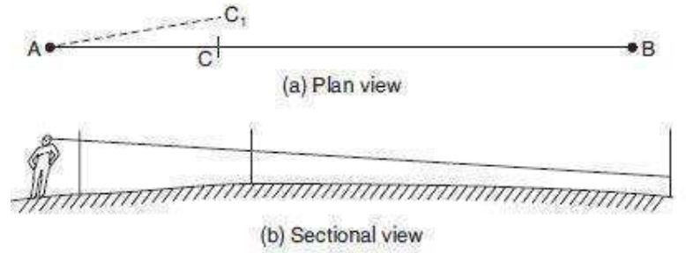

Figure: Direct Ranging

*2. Indirect or Reciprocal Ranging:* Indirect ranging is used when the end stations are not intervisible due to high ground or a hill or if the ends are too long. In such cases, intermediate points can be fixed on the survey line by a process known as reciprocal ranging.

Let A & B be the two stations with rising ground or a hill (Refer Figure). Let two chainmen with ranging rods take up positions at M and P, such that, chainmen at M1 can see both rodsat P1 and B and the chainmen at P1 can see the ranging rods at M1 and A. The chainmen at P1 directs the chainmen at M1 to shift the ranging rod at M2 in line with A and then chainman at M2 directs the chainmen at P1 to shift the ranging rod to P2 in line with B, by successively directing each other to be in line with the end points. Their positions will be changed until finally they are both in line with A & B exactly on line AB. Now the four ranging rods at A M P & B are on same straight line. This method may also be used in ranging a line across a valley or river.

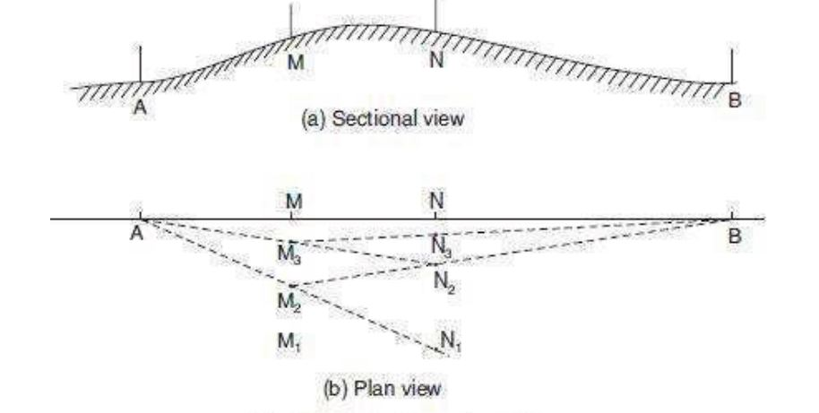

Figure : Indirect or Reciprocal Ranging

Survey Station

Survey stations are of two kinds

1. Main Stations

2. Subsidiary or tie

*Main Stations:* Main stations are the end of the lines, which command the boundaries of the survey, and the lines joining the main stations re called the main survey line or the chain lines.

*Subsidiary or the tie stations:* Subsidiary or the tie stations are the point selected on the main survey lines, where it is necessary to locate the interior detail such as fences, hedges, building etc.

*Tie or subsidiary lines:* A tie line joints two fixed points on the main survey lines. It helps to checking the accuracy of surveying and to locate the interior details. The position of each tie line should be close to some features, such as paths, building etc.

*Base Lines:* It is main and longest line, which passes approximately through the centre of the field. All the other measurements to show the details of the work are taken with respect of this line.

*Check Line:* A check line also termed as a proof line is a line joining the apex of a triangle to some fixed points on any two sides of a triangle. A check line is measured to check the accuracy of the framework. The length of a check line, as measured on the ground should agree with its length on the plan.

Offsets:

These are the lateral measurements from the base line to fix the positions of the different objects of the work with respect to base line. These are generally set at right angle offsets. Itcan also be drawn with the help of a tape. There are two kinds of offsets:

1) Perpendicular offsets, and

2) Oblique offsets.

The measurements are taken at right angle to the survey line called perpendicular or right angled offsets. The measurements which are not made at right angles to the survey line are called oblique offsets or tie line offsets.

Advantages and disadvantages of chain surveying:

Advantages:

• It is simple

• It does not require any costly equipment

• It is adopted for preparing plans for small area

Disadvantages:

• It cannot be used for large areas

• It cannot be used in thick bushy areas with ups and downs.

• Chain surveying is not always accurate.

Compass Surveying – Prismatic Compass:

Whenever a number of base lines are to be run for obtaining the details as in traversing, just linear measurements made by chain surveying will not be sufficient. The angles included between the adjacent lines should also be measured. Compass is one of the instruments used to measure the angles.

Prismatic Compass:

Description:

* A magnetic needle is balanced over a pivot in a circular box of 85 mm to 110 mm in diameter.
* A graduated aluminium ring is attached to the magnetic needle.
* An agate cap keeps the aluminium ring stable.
* The box is covered by a glass lid.
* Object vane and eye vane are provided at diametrically opposite ends.
* Eye vane caries a reflecting prism which can be raised or lowered as desired.
* A vertical horse hair or fine wire is provided at the middle of the object vane.
* The graduations in the aluminium ring are made in the clockwise direction starting with 0o at South and 180o at North with inverted markings.
* A triangular prism fitted below the eye slit enables magnification of readings to suit observer’s eye.
* Based on this prism arrangement, the compass is named prismatic compass.
* Compass is fixed over a tripod with ball and socket arrangement.
* A braked pin is provided below the object vane to damp the oscillations of the magnetic needle while taking readings.



Working Principle:

• The magnetic field aligns itself with the magnetic meridian (N-S direction)

• The line of sight is actually the line joining the object vane and eye vane

• The angle between the N-S direction and the line of sight is observed in the compass

• This angle is actually the angle between N-S direction and the line on the ground

• This angle made by the line with the N-S direction is called the bearing of the line.

• Compass is used to measure the bearing of the different lines from which the angles included between the adjacent lines are computed.

Definitions:

Meridian

The direction of a line is expressed in terms of horizontal angle which the line makes with a reference lne. This reference line is called as meridian.There are 4 types of meridian

*1.True Meridian:* The line joining the true north (geographical north) and true south (geographical south) is called as true meridian.

*2.Magnetic Meridian:* The line joining magnetic north and magnetic south. It is the direction indicated by a freely suspended balanced magnetic needle at that point.

*3.Grid Meridian:* In order to survey a very large area such as a state or a country, true meridian of a central place is often taken as the reference meridian for the whole state or the country. This reference meridian is called as grid meridian.

*4.Arbitrary Meridian:* It is the meridian that is taken in any convinient arbitrary direction. Any reference line can be taken as arbitrary meridian.

Magnetic Declination: Angle between true meridian and magnetic meridian.

Bearing: The bearing of a horizontal line is the angle which it makes with the reference line/meridian. There are 4 types of bearings

1. True Bearing
2. Magnetic Bearing
3. Grid Bearing
4. Arbitrary Bearing

True Bearing:

• True bearing of a line is the angle between the true meridian and the line.

• The angle is always measured in the anticlockwise direction.

Magnetic Bearing:

• It is the angle between the magnetic meridian and the line.

• The angle is always measured in the clockwise direction

• It is the direction shown by a freely suspended magnetic needle

Bearing Designation:

Whole Circle Bearing:

• The bearing of lines measured from the North is called Whole Circle Bearing.

• The angle is reckoned in the clockwise direction from 0o coinciding with the north.

Quadrant Bearing:

• The whole circle is divided into four quadrants.

• The bearing is expressed with N or S as prefix and E or W as suffix.

• Quadrant Bearing is also known as Reduced Bearing.

Bearing of a line:

Fore Bearing and Back bearing:

• Every line has two bearing namely fore bearing and back back bearing

• Fore bearing is the bearing taken in the direction of surveying and Back bearing is the bearing taken in the reverse direction.

• The difference between the fore bearing and the back bearing should be 180o.

• It means that one or both stations of the line are subjected to local attraction.

• Thus, local attraction is the influence caused on the measured bearings of lines due to the presence of materials like railway track, current carrying wires or cables, etc.,

To find QB from WCB:

Exp.1

Solution :

Line PA lies in 1st quadrant.

Quadrant Bearing bearing of PA = N 35o 15’ E

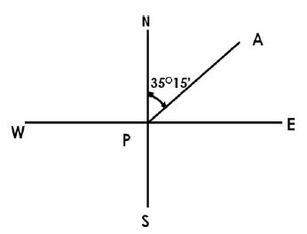

Exp.2

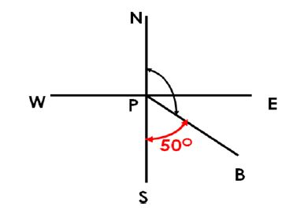

Solution :

Line PB lies in 2nd quadrant.

Quadrant Bearing bearing of PB = S 50o 00’ E

LOCAL ATTRACTION

Detection of local attraction: Local attraction at a place can be detected by observingbearings. If the fore and back bearings of the line differ exactly by 180°, there is no localattraction at either station provided instrumental and observational errors are eliminated.But if this difference is not equal to 180°, then local attraction exists there either at one or atboth ends of the line. The list of materials which cause local attraction are:

(i) Magnetic rock or iron ore,

(ii) Steel structures, iron poles, rails, electric poles and wires,

(iii) Key bunch, knife, iron buttons, steel rimmed spectacles, and

(iv)Chain, arrows, hammer, clearing axe etc.

Electronic Distance Measuring Instruments (EDM)

In surveying, the standard measurement device for many years remained the steel tapemeasure. Newer electronic measuring devices, however, have begun to take the place of the tape. In surveying applications, surveyors can take electronic distance measurements fromhelicopters covering distances and terrain that would have been near impossible with oldermethods.

Theinstrument comprises an electronic distance meter, a unit for determining a vertical angle foraligning the instrument with a measuring point, and a unit for obtaining a horizontal angle for the alignment of the instrument with a measuring point.



Figure: EDM Figure : Total station

Total Station

A total station is an electronic/optical instrument used in modern surveying. The totalstation is an electronic theodolite (transit) integrated with an electronic distance meter (EDM) to read slope distances from the instrument to a particular point.

Coordinate measurement: Coordinates of an unknown point relative to a known coordinate can be determined using the total station as long as a direct line of sight can be established between the two points. Angles and distances are measured from the total station to points under survey, and the coordinates (X, Y, and Z or easting, northing and elevation) of surveyed points relative to the total station position are calculated using trigonometry and triangulation.

Applications:

a. Total stations are mainly used by land surveyors and Civil Engineers, either to record features as in Topographic Surveying or to set out features (such as roads, houses or boundaries).

b. They are also used by archaeologists to record excavations and by police, crime scene investigators, private accident reconstructions and insurance companies to take measurements of scenes.

c. Mining: Total stations are the primary survey instrument used in mining surveying.

**MODULE – III**

**Soil**

Soil is normally referred to as the naturally occurring organic material found in the earth’s surface. It is mainly composed of minerals, nutrients, water and other organic particles and some residues of plants and animals. The soil is the part of earth’s surface which includes disintegrated rock,humus, inorganic and other materials.

for the formation of soil, it takes around hundreds to thousands of years. The soil is usually generated when rocks break up into their constituent parts. When a range of different forces acts on the rocks, they break into smaller parts to form the soil.

The soil is mainly classified by its texture, proportions and different forms of organic and mineral compositions. The soil is basically classified into four types

* Sandy soil
* Clay soil
* Silt soil
* Loamy soil

Sandy Soil

* the first type of soil.
* It consists of small particles of weathered rock.
* Sandy soils are one of the poorest types of soil for growing plants because it has very low nutrient and poor in holding water, which makes it hard for the plant's roots to absorb water.
* This type of soil is very god for the drainage system.

Silt Soil

* Silt which is known to have smaller particles compared to the sandy soil and is made up of rock and other mineral particles which are smaller than sand and larger than clay.
* It is smooth and quite fine quality of the soil that holds water better than sand.

Clay Soil

* Clay is the smallest particles amongst the other two types of soil.
* The particles in the soil are tightly packed together with very little or no airspace..
* This soil has very good water storage quality sand resistance for moisture and air to penetrate into it.
* It is very sticky to the touch when wet but smooth when dried.

Loamy Soil

* It s the combination of sand, silt and clay such that the beneficial properties from each is included.
* It has the ability to retain moisture and nutrient.
* This is also referred to as an agricultural soil.

Soil Classification

Classification of soil can be done by any of the following method

* Particle size classification
* Unified soil classification
* Textural classification
* AASHTO classification
* Highway Research Board or Public Road Association Classifiction
* Indian Standard soil classification

FOUNDATIONS

Objectives of foundation:

* To distribute the total load coming on the structure on a larger area.
* To support the structures
* To give enough stability to the structure against various disturbing forces, such as wind and rain.

Types of foundation

Foundation may be broadly classified as

1. Shallow Foundation

2. Deep Foundation

*Shallow Foundation:* When the depth of the foundation is less than or equal to its width, it is defined as shallow foundation.

*Deep foundation:* Deep foundation consists of pile and pier foundation.Pier foundations are rarely used for buildings. This consists in carrying down through the soil a huge masonry cylinder which may be supported on solid rock.

Types of shallow foundation:

*Isolated column footing:* It is used in framed structures where several columns are to be constructed, isolated buildings can be adopted.

*Wall footing:* It is the footing provided throughout the length of the wall in the load bearing walls, then it is called wall footing.

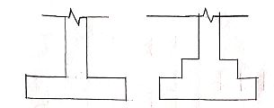

*Stepped Footing:*

* When the ground is sloping, stepped footings are provided.
* It consists of two or more footings of brick or stone masonry and a concrete bed below the ground level.
* The overlap between two layers of foundation concrete slab is equal to the depth of concrete slab or two times the height of the step, whichever is more.



Figure : Stepped footong

*Continuous footing:* In this type of footing, a single continuous RC slab is provided as foundation for three or more columns in a row. This type of footing is more suitable to prevent the differential settlement in the structure.

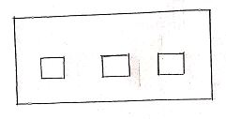

*Strap or Cantilever footing:*

* Used to prevent differential settlement between two footings by providing a strap beam which connects both the footings.

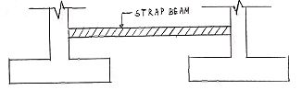

*Raft foundation:*

* It supports many columns or walls.
* Used when soil is weak.
* Generally used over sand

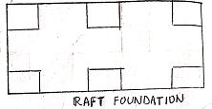

Types of deep foundation

*1. Pile foundation:*

* Pile is an element of construction used as foundation.
* It may be driven in the ground vertically or with some inclination to transfer the load safely.
* Loads are supported in two ways. i.e., either by the effect of friction between the soil and the pile skin or by resting the pile on a very hard stratum.
* The former is called *friction pile* and later one is the *load bearing pile.*

*2.Under reamed pile:*

* Structures build on expansive soils often crack due to the shrinking of the soil.
* Under reamed piles provide a satisfactory solution to the above problem.
* The principle of this type of foundation is to transfer the load to the hard strata which has sufficient bearing capacity to take the load.
* Single and double under reamed piles may also be provided for foundation of structures in poor soils overlying firm soil strata

*3.Cassion or Well foundation:*

* These are box like structure which are sunk from surface of either land or water to the desired depth.
* Inside of this structure is hollow which may be filled with sand and plugged from bottom.

**Irrigation:**

It is the process of artificially supplying water to soil for raising crops.

Irrigation Engineering:The engineering of controlling thevarious natural sources of water, by construction of demand reservoirs, canals and headwork and finally distributing the water to the agriculture fields is called as irrigation engineering.

The necessity of irrigation dependsupon the following points:

* Less Rainfall
* Non-uniform rainfall
* Growing a number of crops during a year
* Growing perennial crops
* Commercial crops with additional water
* Controlled water supply

Advantages & disadvantages of irrigation

Advantages of Irrigation

*Direct advantages*

(i) Increase in food production: Increase in crop yield due to irrigation leads to increase in food production, thus developing people as well as society.

(ii) Protection against drought: The provision of adequate irrigation facilities in any region ensures protection against failure of crops from famine or drought.

(iii) Revenue generation: When regular supply of water is assured for irrigation the cultivators can grow certain superior or high priced crops (like cash crops) in place of inferior or low priced crops. Thus revenue is generated.

(iv)Mixed cropping: Means sowing of two or more crops together in the same field. This practice is followed so that if weather conditions are not favourable for one crop it may be suitable for other crop. But if irrigation facilities are made available, the need of mixed cropping is eliminated

*Indirect advantages*

Power generation: Major river valleys projects are usually planned to provide hydroelectric power together with irrigation. However relatively small quantity of hydroelectric power may also be generated at a small cost on projects which are primarily planned for irrigation.

Transportation: Most of the irrigation canals are provided with unsurfaced roads primarily for purposes of inspection and maintenance. These roads provide a good pathway to the local people. The network of irrigation canals can be used as the most economical means of transportation of goods as well as human beings.

Ground water table: In areas where irrigation facilities are provided due to constant percolation of a portion of water flowing in the canals and also that is supplied to the field, the ground water storage is increased and consequently ground water table is raised.

Employment: During the constructions of irrigation works, employment is provided

*Disadvantages of Irrigation*

* Abundant supply of irrigation water tempts the cultivators to use more water than required
* Excess water supplied to the field would percolate into the soil. Hence, due to constant percolation ground water table would be raised and will lead to water logging
* The ground water can get polluted due to seepage of the nitrates into the ground water (applied to the soil as fertilizers).

Types of irrigation

(1) Surface irrigation

(2) Subsurface irrigation

(1) *Surface irrigation*

* Surface irrigation is defined as the group of water application techniques where water is applied and distributed over the soil surface either by gravity or by pumping
* More than 75% of irrigated lands in India is supplied water by surface irrigation methods.
* This method is best suited to soils with low to moderate infiltration capacities and to lands with relatively uniform terrain.
* Surface irrigation can be further classified into
* Flow irrigation: When the water is available at a higher level, and it is supplied to lower level, by the mere action of gravity, then it is called Flow Irrigation.
* Lift irrigation: If the water is lifted up by some mechanical or manual means, such as by pumps, etc. and then supplied for irrigation, then it is called Lift Irrigation. Use of wells and tubewells for supplying irrigation water fall under this category.

Flow irrigation can be further sub-divided into:

(a) Perennial irrigation (b) Flood irrigation.

(a) Perennial Irrigation

* In perennial system of irrigation, constant and continuous water supply is assured to the crops in accordance with the requirements of the crop, throughout the crop period.
* In this system of irrigation, water is supplied through canal distribution system taking off from above a weir or a reservoir
* When irrigation is done by diverting the river runoff into the main canal by constructing a diversion weir or a barrage across the river, then it is called as direct irrigation. But if a dam is constructed across a river to store water during monsoons, so as to supply water in the off-taking channel during periods of low flow, then it is termed as storage irrigation

(b) Flood Irrigation

* In this method of irrigation, soil is kept submerged and thoroughly flooded with water, so as to cause thorough saturation of the land.
* It is usually practised in delta regions where the river water level during flood is sufficiently high to supply water to the land by flow, or partly by flow and partly by lift.
* This system of irrigation is also called uncontrolled irrigation or inundation irrigation.

(2) Sub-surface Irrigation In this type of irrigation, water does not actually wet the soil surface rather it flows underground and nourishes the plant roots by capillarity.

It may be divided into the following two types () Natural sub-irrigation (ii) Artificial sub-irrigation.

(i) Natural sub-irrigation

• Leakage water from channels, goes underground and during passage through the sub-soil, it own on lower lands, by capillarity. Sometimes, leakage causes the water table to rise up, which helps in irrigation of crops by capillarity.

(ii) Artificial sub-irrigation

When a system of open jointed drains is artificially laid below the soil, so as to supply water to the crops by capillarity, then it is known as artificial sub irrigation. It is a very costly process and hence, adopted on a very small scale.

Methods of irrigation

There are various ways in which the irrigation water can be applied to the fields. Following are the main classifications:

1. Free flooding
2. Border flooding
3. Check flooding
4. Basin flooding
5. Furrow method or furrow irrigation
6. Sprinkler irrigation method
7. Drip irrigation method

(1)Free flooding or Ordinary flooding

* In this method, ditches are excavated in the field, and they may be either on the contour or up and down the slope,Water from these ditches, flows across the field.
* It is sometimes called wild flooding (as the movement of water is not restricted).
* Wild flooding is most suitable for close growing crops, pastures, etc., particularly where the land is steep This method may be used on rolling land (topography irregular) where borders checks, basins and furrows are not feasible

(2) Border flooding

* In this method, the land is divided into a no. of strips, separated by low levees called borders.
* Borders are long, uniformly graded strips of lands,separated by earth bunds. These bunds are to guide the flow of water down the field.
* Water is allowed to flow from the supply ditch into each trip.

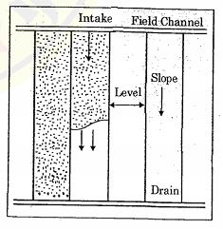

(3) Check flooding

* Check flooding is similar to ordinary.flooding except that the water is controlled by surrounding the check area with low and flat levees.
* Suitable for close growing crops such as jowar or paddy .

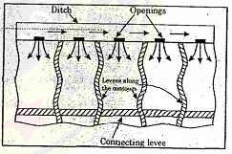

(4) Basin flooding

* This method is a special type of check flooding & adopted specially for orchard trees.
* One or more trees are generally placed in the basin and Shape of the basin can be square rectangular, circular or it may be regular.

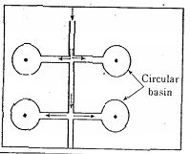

(5) Furrow method or furrow irrigation

* In this method of irrigation, water is applied to the land to be irrigated by a series of furrows, Furrows are small parallel channels, made to carry water for irrigating the crops.
* The crops are usually grown on the ridges between the furrows.

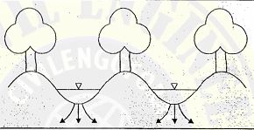

(6)Sprinkler irrigation method

* In this method, the irrigation water is applied to the land in the form of spray, somewhat as in ordinary rain through a network of pipes and pumps.
* The sprinkler irrigation can be used for all the crops except rice and jute.

(7) Drip irrigation method

* One of the latest method of irrigation which is becoming increasingly popular in areas with acute scarcity of irrigation water and salt problems.
* In this method, water and fertilizer is slowly and directly applied to the root zone of the plants.
* It is also known as trickle irrigation.

**Hydraulic Structure**

A hydraulic structure is a structure submerged or partially submerged in any body of water, which disrupts the natural flow of water.

Any hydraulic structure which supplies water to the off-taking canal is called a Headwork

Types:

*1. Storage Headwork:*A Storage headwork comprises the construction of a dam on the river. It stores water during the period of excess supplies and releases it when demand overtakes available supplies.

*2. Diversion Headwork:*The works which are constructed at the head of the canal , in order to divert the river water towards the canal, so as to ensure regulated continuous supply of silt free water with certain minimum head into that canal is called as diversion head works.

a) Temporary Spurs or bunds:- which are temporary and constructed every year after floods

b) Permanent Weirs and Barrages

DAM

Dams are massive barriers built across rivers and streams to confine and utilize the flow of water for human purposes. These purposes may be Irrigation, Hydropower, Water-supply, Flood Control, Navigation, Fishing and Recreation. This confinement of water creates lakes or reservoirs.

Classification of Dam

1. Based on function

* Storage dam or impounding dam
* Detention dam
* Diversion dam
* Coffer dam
* Debris dam

2. Based on hydraulic design

* Overflow dam
* Non overflow dam

3. Based on material of construction

* Rigid dam
* Non rigid dam

4. Based on structural behaviour

* Gravity dam
* Arch dam
* Buttress dam
* Embankment dam

CANAL

A canal is defined as an artificial channel constructed on the ground to carry water from a river or another canal or a reservoir to the fields.

Classification of canal

A)Classification based on alignment:

1) Ridge canal

2) Side slope canal.

B) Classification based on position:

1) Main Canal

2) Branch Canal

3) Major Distributary

4) Minor distributary

5) Water Course

6) Head Work

C)Classification based on function

1) Irrigation Canal

2) Navigation Canal

3) Power Canal

4) Feeder Canal

SPILLWAY

A spillway is a hydraulic structure built at dam site for diverting the surplus water from a reservoir ,if the store after it has been filled to its maximum capacity.

Types of spillway

* Ogee spillway
* Straight drop spillway
* Side channel spillway
* Chute spillway

WEIR

The weir is a hydraulic structure constructed across the river to raise its water level and divert the water into the canal.If a weir also stores water for tiding over small periods of short supplies, it is called as storage weir.

The main difference between a storage weir and dam is only in height and duration for which supply is stored.

BARRAGES

A barrage is a weir that has adjustable gates installed over top of it, to allow different water surface heights at different times. The water level is adjusted by operating the adjustable gates.

It has small crest with gauges (mechanically operated gates) which are often used to control and stabilize water flow for irrigation systems.

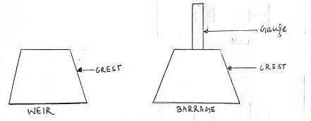

Cross Drainage Works

In an Irrigation project, when the network of main canals, branch canals, distributaries, etc.are provided, then these canals may have to cross the natural drainages like rivers, streams, nallahs, etc. at different points within the command of the project. The crossing of the canals with such obstacle cannot be avoided. So, suitable structures must be constructed at the crossing point for the easy flow of water of the canal and drainage in the respective directions. These structures are known as cross-drainage works.

Irrigation Canals while carrying water from headworks to crop field, have to cross few natural drainage streams, nallah, etc.. To cross those drainages safely by the canals, some suitable structures are required to construct.

Works required to construct to cross the drainage are called Cross Drainage Works (CDW). At the meeting point of canals and drainages, bed levels may not be same.

Depending on their bed levels, different structures are constructed and accordingly they are designated by different names.

* Types of Cross Drainage Works Type I (Irrigation canal passes over the drainage)

(a) Aqueduct (b) Siphon Aqueduct

* Type II (Drainage passes over the irrigation canal)

(a) Super passage (b) Siphon super passage

* Type III (Drainage and canal intersection each other of the same level)

(a) Level crossing (b) Inlet and outlet

Type-I Irrigation canal passes over the Drainage:

This condition involves the construction of following

*Aqueduct*

The hydraulic structure in which the irrigation canal is taken over the drainage (such as river, stream etc.) is known as aqueduct. This structure is suitable when bed level of canal is above the highest flood level of drainage. In this case, the drainage water passes clearly below the canal.

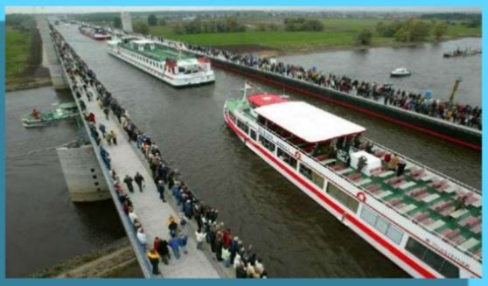

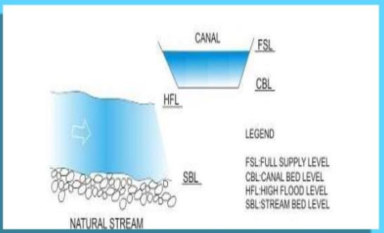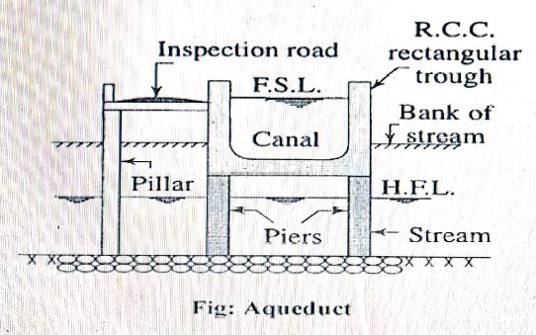

*Siphon Aqueduct*

In a hydraulic structure where the canal is taken over the drainage, but the drainage water cannot pass clearly below the canal. It flows under siphonic action. So, it is known as siphon aqueduct. This structure is suitable when the bed level of canal is below the highest flood level.

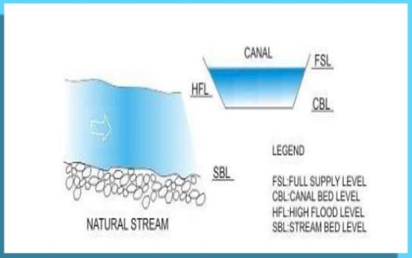

Type-II Drainage Passes over the irrigation Canal.

*Super Passage*

The hydraulic structure in which the drainage is taken over the irrigation canal is known as super passage. The structure is suitable when the bed level of drainage is above the full supply level of the canal. The water of the canal passes clearly below the drainage.

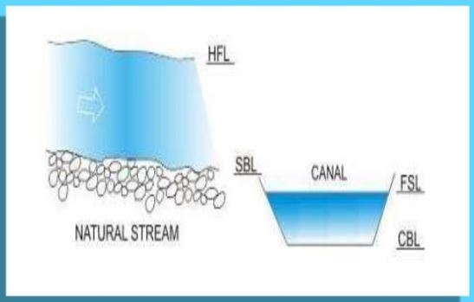

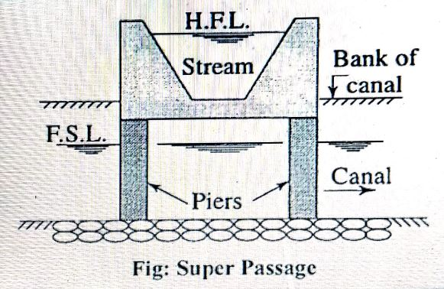

*Siphon Super Passage*

The hydraulic structure in which the drainage is taken over the irrigation canal, but the canal water passes below the drainage under siphonic action is known as siphon super passage. This structure is suitable when the bed level of drainage is below the full supply level of the canal.

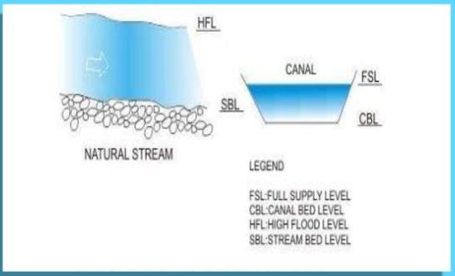

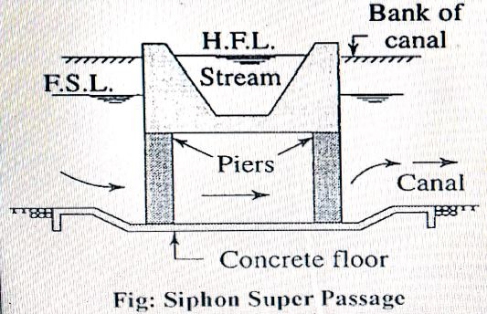

Type III Drainage and Canal Intersect each other at the same level.

Level Crossings

When the bed level of canal and the stream are approximately the same and quality of water in canal and stream is not much different, the cross drainage work constructed is called level crossing where water of canal and stream is allowed to mix. With the help of regulators both in canal and stream, water is disposed through canal and stream in required quantity. Level crossing consists of following components (i) crest wall (ii) Stream regulator (iii) Canal regulator.

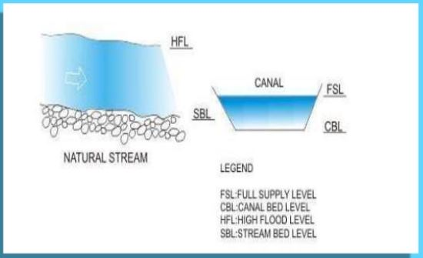

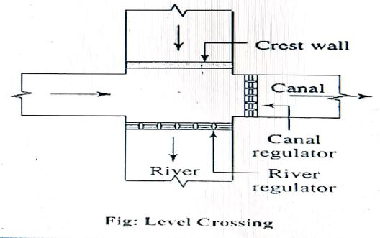

*Inlet and Outlet*

When irrigation canal meets a small stream or drain at same level, drain is allowed to enter the canal as in inlet. At some distance from this inlet point, a part of water is allowed to drain as outlet which eventually meets the original stream.

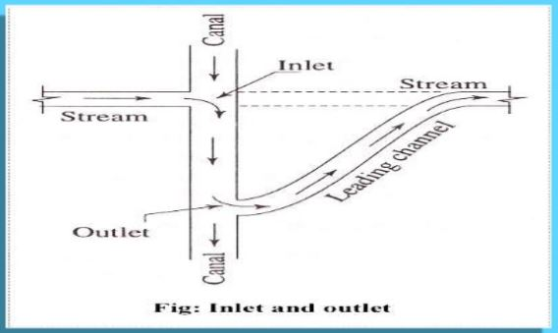

The bed and banks between inlet and outlet are also protected by stone pitching This type of CDW is called Inlet and Outlet.

**MODULE - IV**

INTRODUCTION

From the beginning of history, human sensitivity has revealed an urge for mobility leading to a measure of Society's progress. The history of this mobility or transport is the history ofcivilization. For any country to develop with right momentum modem and efficient Transport asa basic infrastructure is a must. Transport (British English) or transportation (American English) is the movement of people and goods from one place to another.

Modes of Transport

Planning and Design Aspects of Transportation Engineering:

The planning aspects of transportation engineering relate to elements of urban planning, and involve technical forecasting decisions and political factors. Technical forecasting of passenger travel usually involves an urban transportation planning model, requiring the estimation of trip generation (how many trips for what purpose), trip distribution (destination choice, where is the traveler going), mode choice (what mode is being taken), and route assignment (which streets or mutes are being used). More sophisticated forecasting can include other aspects of travelerdecisions, including auto ownership, trip chaining (the decision to link individual trips together in a tour) and the choice of residential or business location (known as land use forecasting). Passenger trips are the focus of transportation engineering because they often represent the peak of demand on any transportation system.

Before any planning occurs the Engineer must take what is known as an inventory of the area or if it is appropriate, the previous system in place. This inventory or database must include information on (1) population, (2) land use, (3) economic activity. (4) transportation facilities and services, (5) travel patterns and volumes. (6) laws and ordinances, (7) regional financial resources (8) community values and expectations. These inventories help the engineer create business models to complete accurate forecasts of the future conditions of the system review.

Transport design

Transport engineers face multi-faceted design decisions when they are designing optimized transport infrastructure networks. These might relate to:

* The physical expansion of transport facilities, such as lane width or the number of lanes, for a roadway.
* The materials and thickness used in pavements.
* The geometry of a facility, such as a roadway, rail line or airport.
* Road pricing schemes.
* Deploying information-based technology.

In all design decisions, multiple performance measures, cost metrics and safety criteria must be considered and weighed.

Transport Operations

Transport operations, whether for road, rail, port or air traffic, are designed to minimize travel delays, improve safety, reduce emissions and enhance reliability, as well as taking other considerations into account. Transport operation decisions involve:

* Optimizing traffic signals
* Setting specific tolls
* Designing traffic signs and markings

With the development of new Intelligent Transportation Systems (ITS), transport engineers use tools including advanced traveller information systems (such as variable message signs). Advanced traffic control systems (such as ramp meters) and vehicle to-vehicle (V2V) communications to optimize the performance of the transport system.

Highway Engineering

Highway engineering is an engineering discipline branching from civil engineering that involves the planning, design, construction, operation, and maintenance of roads, bridges, and tunnels to ensure safe and effective transportation of people and goods. Highway engineers must take into account future traffic flows, design of highway intersections/interchanges, geometric alignment and design, highway pavement materials and design, structural design of pavement thickness, and pavement maintenance. The most appropriate location, alignment, and shape of a highway are selected during the design stage. Highway design involves the consideration of three major factors (human, vehicular, and roadway) and how these factors interact to provide a safe highway.

Human factors include reaction time for braking and steering, visual acuity for traffic signs and signals, and car-following behaviour. Vehicle considerations include vehicle size and dynamics that are essential for determining lane width and maximum slopes, and for the selection of design vehicles.

Highway engineers design road geometry to ensure stability of vehicles when negotiating curves and grades and to provide adequate sight distances for undertaking passing maneuvers along curves on two-lane, two-way roads.

Railway Engineering

It is a branch of civil engineering concerned with the design, construction, maintenance, and operation of railways. Railway engineering includes elements of civil, mechanical, industrial,and electrical engineering, Railway engineers handle the design, construction, and operation of railroads and mass transit systems that use a fixed guideway (such as light rail or even monorails). Typical tasks would include determining horizontal and vertical alignment design, station location and design, construction cost estimating, and establishment of signaling &controlling system. Railroad engineers can also move into the specialized field of train dispatching which focuses on train movement control. Railway engineers also work to build a cleaner and safer transportation network by reinvesting and revitalizing the rail system to meet future demands.

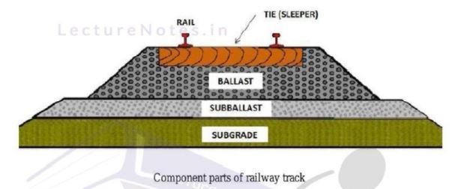

Airport Engineering

Airport engineers design and construct airports. Airport engineers must account for the impacts and demands of aircraft in their design of airport facilities. These engineers must use the analysis of predominant wind direction to determine runway orientation, determine the size of runway border and safety areas, different wing tip to wing tip clearances for all gates and must designate the clear zones in the entire port.

An airport system plan is a representation of the aviation facilities required to meet the immediate and future needs of a metropolitan area, region, state, or country. The system plan presents the recommendations for the general location and characteristics of new airports and heliports and the nature of expansion for existing ones to meet forecasts of aggregate demand. It identifies the aviation role of existing and recommended new airports and facilities. It includesthe timing and estimated costs of development and relates airport system planning to the policy and objectives of the relevant jurisdiction. Its overall purpose is to determine the extent type, nature, location, and timing of airport development needed to establish a viable, balanced, and integrated system of airports. It also provides the basis for detailed airport planning such as that contained in the airport master plan. The airport system plan provides both broad and specific policies, plans, and programs required to establish a viable and integrated system of airports to meet the needs of the region.

The objectives of the system plan include:

1. The orderly and timely development of a system of airports adequate to meet present and future aviation needs and to promote the desired pattern of regional growth relative to industrial employment, social, environmental and recreational goals development aviat meet role in a balanced and multimodal transportation

2. The system to foster the overall goals of the area as reflected in the transportation system plan and comprehensive development plan.

3. The protection and enhancement of the environment through the location and expansion of aviation facilities in a manner which avoids ecological and environmental impairment.

4. The provision of the framework within which specific airport programs may be developed consistent with the short-and long-range airport system requirements.

5. The implementation of land-use and airspace plans which optimize these resources in an often constrained environment.

6. The development of long-range fiscal plans and the establishment of priorities for airport financing within the government budgeting process.

The elements in a typical airport system planning process include the following:

1. Exploration of issues that impact aviation in the study area

2. Inventory of the current system

3. Identification of air transportation needs Notes.in

4. Forecast of system demand

5. Consideration of alternative airport systems

6. Definition of airport roles and policy strategies

7. Recommendation of system changes, funding strategies, and airport development

8. Preparation of an implementation plan

Traffic Engineering

Traffic engineering is a branch of civil engineering that uses engineering techniques to achieve the safe and efficient movement of people and goods on roadways. It focuses mainly on research for safe and efficient traffic flow, such as road geometry, sidewalks and crosswalks, cycling infrastructure, traffic signs, road surface markings and traffic lights. Traffic engineering deals with the functional part of transportation system, except the infrastructures provided.

Typical traffic engineering projects involve designing traffic control device installations and modifications, including traffic signals, signs, and pavement markings. However, traffic engineers also consider traffic safety by investigating locations with high crash rates and developing countermeasures to reduce crashes. Traffic flow management can be short-term (preparing construction traffic control plans, including detour plans for pedestrian and vehicular traffic) or long-term (estimating the impacts of proposed commercial developments on traffic patterns). Increasingly, traffic problems are being addressed by developing systems for intelligent transportation systems, often in conjunction with other engineering disciplines, such as computer engineering and electrical engineering.

Traffic engineering is closely associated with other disciplines:

* Transport engineering
* Pavement engineering
* Bicycle transportation engineering
* Highway engineering
* Transportation planning
* Urban planning
* Human factors engineering.

Urban Planning

Transportation Engineering and Urban Planning are closely related fields. Transportation engineering deals with the planning, design, construction, and operation of transportation systems, while urban planning is concerned with broader issues that are related with transportation. These issues include land use, environment, economic development, community housing and development, urban design, and other social, economic and political issues at the local, region, state and national level.